

**EQUIPMENT REQUIRED:**

* Suitable running shoes.
* On grass or tarmac accurately measure out 100m in a straight line, mark the start and finish line and individual lanes with tape or cones.

**AGE CATEGORIES:**

* Key Stage 3 - Year 7,8 &9

**TEAM SIZE:**

* Unlimited participants
* Please encourage as many children as possible to get involved whilst adhering to your school’s individual risk assessments on social distancing and making sure that all children can compete in a safe environment.

**RULES for 100m Sprint:**

* For ease of judging finishing positions and recording times there should be a maximum of 6 athletes per heat.
* All athletes are put in individual lanes and must run the race in their own lane.
* The start should be explained to the athletes.
* Athletes take their marks behind the start line.
* The Starter will give them the instructions “On your marks, Set, Go”. (“Go” can be a clacker, whistle, starting pistol or arm dropped).
* It is a false start if one or more of the athletes starts to run before the Starter says “Go”. If that happens all the athletes in that race are recalled and the race is started again.

**SCORING:**

* 5 Boys and 5 Girls compete as a team with the scores of the top 5 boys and top 5 girls over the four events added together to give the team score.
* All times should be rounded up to the nearest 0.1 second so 11.21 becomes 11.3.
* A Runner takes the results back to the Scorer who will input them onto the computer spreadsheet.

**DEADLINE:**

* The deadline for all entries is Friday 9th July Please enter by completing the OFFICIAL Results spreadsheet on the team BEDS&LUTON website and emailing to your SGO

**100m Sprint**

**800m Run**

**EQUIPMENT REQUIRED:**

* Suitable running shoes

**AGE CATEGORIES:**

* Key Stage 3 - Year 7,8 &9

**TEAM SIZE:**

* Unlimited participants
* Please encourage as many children as possible to get involved whilst adhering to your school’s individual risk assessments on social distancing and making sure that all children can compete in a safe environment.

**RULES 800m:**

* For ease of judging finishing positions and recording times there should be a maximum of 12 athletes per heat.
* On a 400m track the athletes start at the 800m start, this is the finishing line for the 100m.
* Athletes are not allocated lanes but start behind a slightly curved line.
* The start should be explained to the athletes.
* The Starter will give them the instructions “On your marks, Go”. (“Go” can be a clacker, whistle, starting pistol or arm dropped).

**SCORING:**

* 5 Boys and 5 Girls compete as a team with the scores of the top 5 boys and top 5 girls over the four events added together to give the team score.
* All times should be rounded up to the nearest 1 second so 2 minutes 45.7 seconds becomes 2.46.

**DEADLINE:**

* The deadline for all entries is Friday 9th July Please enter by completing the OFFICIAL Results spreadsheet on the team BEDS&LUTON website and emailing to your SGO





**Standing Long Jump**

**EQUIPMENT REQUIRED:**

* Measuring Tape / Standing Long Jump Mat

**AGE CATEGORIES:**

* Key Stage 3 - Year 7,8 & 9

**TEAM SIZE:**

* Unlimited participants
* Please encourage as many children as possible to get involved whilst adhering to your school’s individual risk assessments on social distancing and making sure that all children can compete in a safe environment.

**RULES:**

* The athlete must stand with both feet behind the take-off datum line.
* Techniques involving a crouch or rocking motion prior to the jump are permitted provided that both feet are alongside each other and retain contact with the mat until the start of the jump.
* The athlete should jump as far as possible from a standing position, with a two footed take off.
* The athlete must land on the mat with both feet. If an athlete’s foot lands outside the graduated area and the judges are able to measure the jump, it should be recorded as a good trial.
* The athlete is not required to hold the landing position and may step forward after the jump. Should the athlete step back, fall back or touch the mat or floor behind their heel, a no jump should be recorded.
* Measurement is taken from the take off line to the back of the closest heel on landing*.*
* The athlete is permitted 3 consecutive trials.

**SCORING:**

* Record Distance jumped Centimetres
* 5 Boys and 5 Girls compete as a team with the scores of the top 5 boys and top 5 girls over the four events added together to give the team score.

**DEADLINE:**

* The deadline for all entries is Friday 9th July Please enter by completing the OFFICIAL Results spreadsheet on the team BEDS&LUTON website and emailing to your SGO

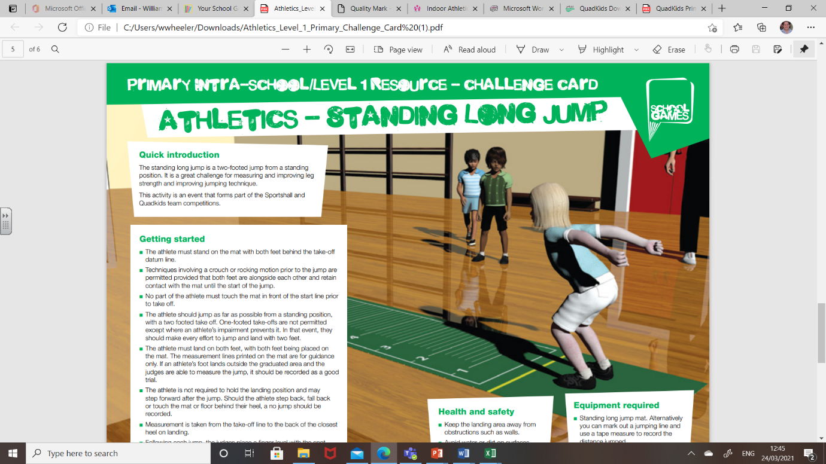



**Vortex Throw**

**EQUIPMENT REQUIRED:**

* Three vortex howlers.
* Three throw markers.
* 1 x 50m tape measure.
* Pegs/cones for each athlete.

**AGE CATEGORIES:**

* Key Stage 3 - Year 7,8 &9

**TEAM SIZE:**

* Unlimited participants
* Please encourage as many children as possible to get involved whilst adhering to your school’s individual risk assessments on social distancing and making sure that all children can compete in a safe environment.

**RULES:**

* If using a javelin throwing sector there are no set up requirements.
* On grass an area at least 55 metres long x 15 metres wide should be marked out using tape or cones. The throwing area should be positioned such that if a throw goes astray it cannot land on the running area and injure any athletes.
* Special care should be taken on grass if it is wet to ensure that athletes do not slip over and injure themselves.
* The athlete can throw the Vortex Howler from a standing position or run up and throw it.
* The athlete must not step onto or cross the marked throwing line.
* Each athlete gets 3 consecutive throws.
* The athlete’s foot must not touch or cross the marked throwing line nor can the Vortex Howler land outside the javelin sector or marked throwing area, if either of these things happen it is a “no throw “ and will not be measured.

**SCORING:**

* 5 Boys and 5 Girls compete as a team with the scores of the top 5 boys and top 5 girls over the four events added together to give the team score.
* If using a marked grass area the throw should be measured in a straight line from the peg to the edge of the line closest to the side from which the athlete threw.

**DEADLINE:**

* The deadline for all entries is Friday 9th July Please enter by completing the OFFICIAL Results spreadsheet on the team BEDS&LUTON website and emailing to your SGO





**4x100 Relay (Optional)**

**EQUIPMENT REQUIRED:**

* Suitable footwear to run in.

**AGE CATEGORIES:**

* Key Stage 3 - Year 7,8 &9

**TEAM SIZE:**

* Unlimited participants
* Please encourage as many children as possible to get involved whilst adhering to your school’s individual risk assessments on social distancing and making sure that all children can compete in a safe environment.

**RULES:**

* If an athletics track is not being used use the area that has been marked out for the 100m Sprint.
* Races are run for both boys and girls. Each teams consists of either 4 boys or 4 girls.
* If an athletics track is being used: o the athletes will go to the appropriate relay stations, this means the athletes do not start level with other, they run off a stagger.
* The first athlete starts with the baton. o the baton must change hands within the marked relay boxes, “ticks” on the track usually indicate these.
* If a marked 100m Sprint is being used: o two athletes are positioned on the start line and two on the finish line in the adjacent lane. o the first athlete starts with the baton.
* The baton must change hands within the marked relay boxes, “ticks” on the track usually indicate these.
* The first boy or girl in each team stands behind the start line with the baton in his or her hand.
* The first boy or girl runs with the baton to the second boy or girl who takes the baton and so on until all four athletes have run.
* Each athlete must run the race in his or her allocated lane.

**SCORING:**

* 5 Boys and 5 Girls compete as a team with the scores of the top 5 boys and top 5 girls over the four events added together to give the team score

**DEADLINE:**

* The deadline for all entries is Friday 9th July Please enter by completing the OFFICIAL Results spreadsheet on the team BEDS&LUTON website and emailing to your SGO

