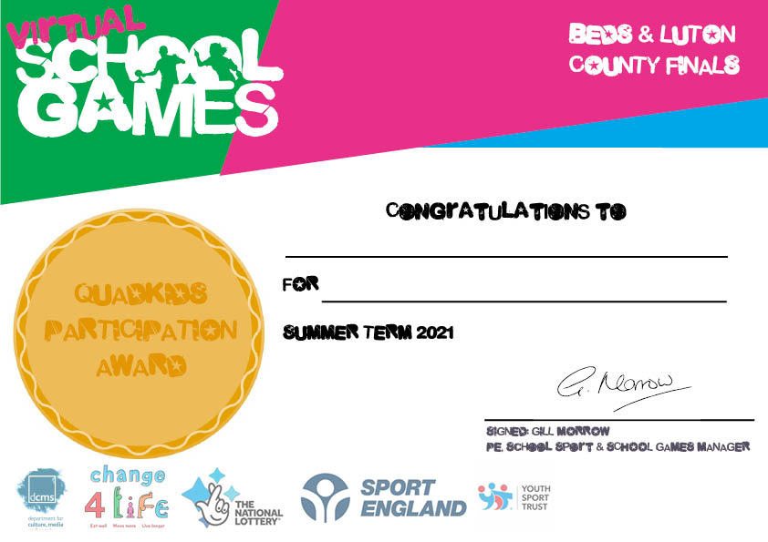

**Taking part in the Virtual School Games QuadKids**

**Name here**