

**EQUIPMENT REQUIRED:**

* Suitable running shoes.
* On grass or tarmac accurately measure out 75m & 50m in a straight line, mark the start and finish lines and individual lanes with tape or cones.

**AGE CATEGORIES:**

* Lower Key Stage 2 - Year 3&4 - 50m Sprint
* Upper Key Stage 2 -Year 5&6 - 75m Sprint

**TEAM SIZE:**

* Unlimited participants
* Please encourage as many children as possible to get involved whilst adhering to your school’s individual risk assessments on social distancing and making sure that all children can compete in a safe environment.

**RULES for 75m and 50m Sprint:**

* For ease of judging finishing positions and recording times there should be a maximum of 6 athletes per heat.
* All athletes are put in individual lanes and must run the race in their own lane.
* The start should be explained to the athletes.
* Athletes take their marks behind the start line.
* The Starter will give them the instructions “On your marks, Set, Go”. (“Go” can be a clacker, whistle, starting pistol or arm dropped).
* It is a false start if one or more of the athletes starts to run before the Starter says “Go”. If that happens all the athletes in that race are recalled and the race is started again.

**SCORING:**

* 5 Boys and 5 Girls compete as a team with the scores of the top 5 boys and top 5 girls over the four events added together to give the team score.
* All times should be rounded up to the nearest 0.1 second so 11.21 becomes 11.3.
* A Runner takes the results back to the Scorer who will input them onto the computer spreadsheet.

**DEADLINE:**

* The deadline for all entries is Friday 9th July Please enter by completing the OFFICIAL Results spreadsheet on the team BEDS&LUTON website and emailing to your SGO

**QUADKIDS – 9th July**

**EQUIPMENT REQUIRED:**

* Suitable running shoes

**AGE CATEGORIES:**

* Lower Key Stage 2 - Year 3&4 – 400m Run
* Upper Key Stage 2 -Year 5&6 – 600m Run

**TEAM SIZE:**

* Unlimited participants
* Please encourage as many children as possible to get involved whilst adhering to your school’s individual risk assessments on social distancing and making sure that all children can compete in a safe environment.

**RULES UKS2 600m:**

* On a 400m track it’s one and half laps
* On a 200m track it’s 3 full laps
* On grass it must be accurately measured, the lap should be marked with tape or cones and for ease of running and safety there should be no sharp corners
* The Starter will give them the instructions “On your marks, Go”. (“Go” can be a clacker, whistle, starting pistol or arm dropped).

**RULES LKS2 400m:**

* On a 400m track it’s one full lap
* On a 200m track it’s 2 full laps
* On grass it must be accurately measured, the lap should be marked with tape or cones and for ease of running and safety there should be no sharp corners
* The Starter will give them the instructions “On your marks, Go”. (“Go” can be a clacker, whistle, starting pistol or arm dropped).

**SCORING:**

* 5 Boys and 5 Girls compete as a team with the scores of the top 5 boys and top 5 girls over the four events added together to give the team score.
* All times should be rounded up to the nearest 1 second so 2 minutes 45.7 seconds becomes 2.46.

**DEADLINE:**

* The deadline for all entries is Friday 9th July Please enter by completing the OFFICIAL Results spreadsheet on the team BEDS&LUTON website and emailing to your SGO

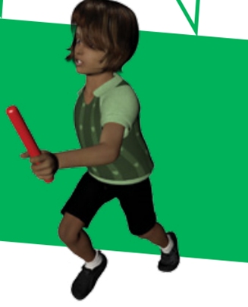



**EQUIPMENT REQUIRED:**

* Measuring Tape / Standing Long Jump Mat

**AGE CATEGORIES:**

* Lower Key Stage 2 - Year 3&4
* Upper Key Stage 2 -Year 5&6

**TEAM SIZE:**

* Unlimited participants
* Please encourage as many children as possible to get involved whilst adhering to your school’s individual risk assessments on social distancing and making sure that all children can compete in a safe environment.

**RULES:**

* The athlete must stand with both feet behind the take-off datum line.
* Techniques involving a crouch or rocking motion prior to the jump are permitted provided that both feet are alongside each other and retain contact with the mat until the start of the jump.
* The athlete should jump as far as possible from a standing position, with a two footed take off.
* The athlete must land on the mat with both feet. If an athlete’s foot lands outside the graduated area and the judges are able to measure the jump, it should be recorded as a good trial.
* The athlete is not required to hold the landing position and may step forward after the jump. Should the athlete step back, fall back or touch the mat or floor behind their heel, a no jump should be recorded.
* Measurement is taken from the take off line to the back of the closest heel on landing*.*
* The athlete is permitted 3 consecutive trials.

**SCORING:**

* Record Distance jumped Centimetres
* 5 Boys and 5 Girls compete as a team with the scores of the top 5 boys and top 5 girls over the four events added together to give the team score.

**DEADLINE:**

* The deadline for all entries is Friday 9th July Please enter by completing the OFFICIAL Results spreadsheet on the team BEDS&LUTON website and emailing to your SGO

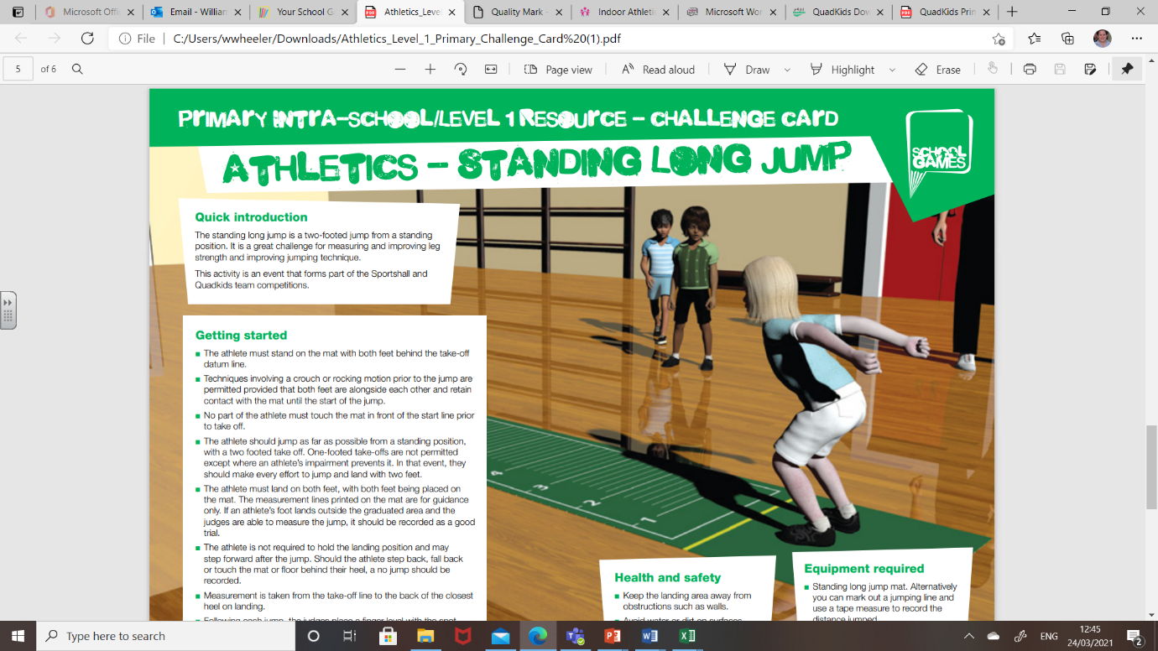



**EQUIPMENT REQUIRED:**

* Three vortex howlers.
* Three throw markers.
* 1 x 50m tape measure.
* Pegs/cones for each athlete.

**AGE CATEGORIES:**

* Lower Key Stage 2 - Year 3&4
* Upper Key Stage 2 -Year 5&6

**TEAM SIZE:**

* Unlimited participants
* Please encourage as many children as possible to get involved whilst adhering to your school’s individual risk assessments on social distancing and making sure that all children can compete in a safe environment.

**RULES:**

* The vortex howler is thrown from a standing position with both feet behind the throwing line and in contact with the floor.
* Ensure that the challenge is set in plenty of space where other athletes or spectators will not walk into the throwing area.
* Each athlete will get three consecutive throws.
* The athlete must throw the vortex howler overarm in a ball throw/javelin action.
* The throw is measured from the front of the throwing line to where the tip of the howler first makes contact with the ground.
* The distance is measured in metres and always down to the nearest metre. Mark each throw with a cone. Only move the cone if the next throw is greater.
* Only the longest throw out of the three will count toward the score.
* It is safe to allow the athletes to collect their own vortex howlers once all competitors have had their turn.

**SCORING:**

* 5 Boys and 5 Girls compete as a team with the scores of the top 5 boys and top 5 girls over the four events added together to give the team score.

**DEADLINE:**

* The deadline for all entries is Friday 9th July Please enter by completing the OFFICIAL Results spreadsheet on the team BEDS&LUTON website and emailing to your SGO

