**Luton Phase 4 Mapping Case Study**

**Effective Use of Sports Premium Funding – using the funding to upskill class teachers**

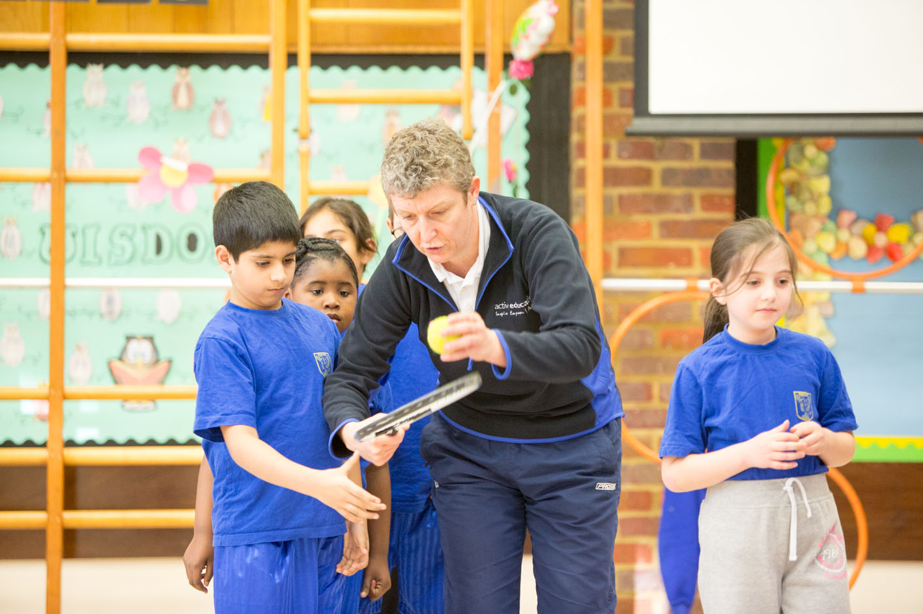

**levant photo/video link**

**Impact**

The main impact reported was on the confidence of teachers to teach high quality lessons.

Also children at the school experience a wealth of sports within curriculum time and during extra curriculum time. As part of the school experience every child and adult within the school is part of a inter house team. The four teams were chosen by the pupils in 2014 and aim to inspire pupils to achieve, create competition and a sense of pride. The four house teams are linked to famous sporting grounds / stadiums in England. During this academic year all children will visit their stadiums to inspire for the future.

Sporting legends Gail Emms and Nathan Fox have visited the school to share their sporting experiences and inspire children for the future.

**Quote – Staff**

‘I have learnt so much and really enjoyed the lessons’

‘I have now considered how changing time can be more focused – by using the interactive whiteboard’

‘I have really seen the progression of the children through the 6 weeks of lessons’

**Quote – Pupil(s)**

‘I love PE lessons with Mr King’

‘We have visited Wembley stadium and Lords Cricket ground. We had a tour of the stadium and sat in the Royal Box!’

‘I am in Wembley team and went to the stadium. We walked out through the tunnel to the pitch!’

**Background**

The school is larger than the average-sized primary school. Most pupils come from Asian or British Asian backgrounds of which most of these pupils speak English as an additional language. There are a small proportion of pupils who are at the early stages of learning English. The proportion of disadvantaged pupils who are supported by the pupil premium is above average. The proportion of disabled pupils and those who have special educational needs is broadly average.

The school employs a full time PE specialist teacher and an experienced coach to teach PE in a variety of year groups. Teachers work alongside the specialist teachers to up skill their knowledge of PE teaching and extra mentoring is given wherever required.

**Actions**

The headteacher and PE coordinator recognised that there were members of staff who were highly motivated and experienced classroom practitioners but did not have the expertise, knowledge or confidence to deliver HQ PE curriculum lessons.

Experienced practitioners were brought in to work 1 on 1 basis with individual teachers during the course of their lessons over a period of 6 weeks per teacher. The benefits of this included:

* Teachers working with their own class so staff can see the progression over time and how things work in practice.
* Teachers were able to increase their ability to deliver HQ lessons by focusing on their own areas for improvement.
* The topic they would like to work on can be specifically tailored to their own and children’s needs.
* No further time out of class or after school is required for the teacher (other than feedback and planning for the next lesson).

Teachers and experienced PE staff had support, so even those confident in the delivery of PE could gain different ideas and ways to deliver HQ PE.

**How partners are supporting the school/cluster of schools to embed and sustain the activity**

The school is continuing to invest its PE and sports premium funding into upskilling teachers. The headteacher recognises that investing in his high quality staff is the best way to sustain and embed good practice across the school and to deliver against whole school improvement outcomes. Quality time is also given to the PE team is share new ideas, planning and ideas to deliver a range of activities to inspire the children to participate in sport outside of the school day. Also sporting facilities are vast across the school so children can access curriculum activities in all weather conditions.