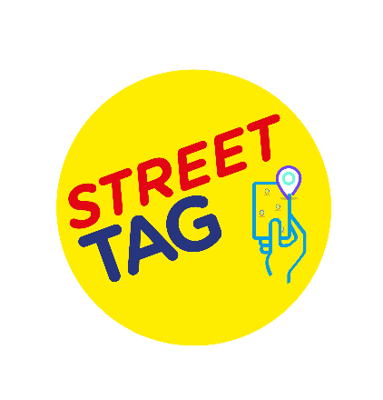


Frequently Asked Questions

Q: How much cost is involved to get our school onboard on the program.
A. It is FREE for your school to participate.
Your school can have up to 250 participants in your school team (these can include parents, children, and staff). Schools with a population size of fewer than 100 pupils are encouraged to partner with other local small schools to maximize the opportunity for both of your schools.

Q. What happens if the school team is full of 250 participants? Can the school have more than one team?
A. A school can have more than 1 team once the initial team is full. Please let us know once your school team reaches 225 participants. We will release another new team with 250 places.
Please Note: Both teams will be counted as individual teams on the leaderboard. We cannot merge them at the end of the season.

Q: How does the school team earn points?
A. With Street Tag, participants record the distance they walk, run, or cycle by collecting virtual tags with their smartphone at various locations, watching their total distance accumulate to climb up their local Schools leaderboard; steps are converted into points by syncing their steps into the Street Tag app.
This is designed to encourage families to walk and cycle to school, to be physically active, to connect with green spaces, and is an opportunity to rediscover their local area as well as earning rewards for their school.

Q: How long does one season last?
A. Each season runs for 14 to 16 weeks.

Q: Is the app safe to use in the current situation of Covid and social distancing?
A. The beauty of the app is that you can participate in it as an individual or with your own family towards your school team. None of the features of the app promotes a congregation of a group of people at a specific location for physical activities.

Q. Does the (app) work on other devices such as laptops, tablets, and iPads?
A. The Street Tag app is only available on the Apple IOS store and the Google Play Store. The app can be used on any device that runs the mobile operating system of these two platforms, this includes but not limited to Android phones, iPhones, the iPad, and some Android tablets with the right specifications of the Android operating system.

Q. Will the app work without the internet?
The Street Tag app requires the internet to function. Street Tag is due to announce an additional service in early 2021 that will support users without internet access to use Street Tag, such as families and the elderly.

Q: How can a parent scan the QR code given by the school to join Street Tag?
A.Please follow these steps to join the school team.

- Download the App “Street Tag” from the Play Store/ App Store.
- Click on sign up.
- Fill in your details.
- The password should be at least 8 characters with 1 special character, 1 upper case, and 1 number.
- Click YES for Team QR Code.
- Scan the school QR Code.
- Click Sign Up
- Verify either by email or phone number.
- Fill in the questionnaire.

Q: How to add a child into a parent account?
A. Parents/Guardians, please follow these steps to add a child as a player into the team.
1. Create an Email ID for your child.
2. A parent can add a max of 2 children as players C1 and C2.
3. Click on the 'Add a child' icon in the settings of the app.
4. Fill in all the details to add a player.
5. Go to the app menu and click on Settings > then click Profile.
6. Select Add C1 and C2 option to complete activation.
Once a child is added as a player. You will notice C1/ C2 option appearing on your main screen.
While tagging with your children, please tap on C1/C2 on the home screen to scan a tag for them.

Q: If a parent of primary age children adds 2 children to their account, does that count as one participant (as one account) out of the 250 max for a school or two?

A. This will count as three accounts. As each account is still unique with its own profile, points accumulation even if they are connected to one parent or guardian account.

Q: How do we check our school team points?
A. You can check your points by visiting the Leaderboard accessible through the side menu, alternatively, click the dashboard icon at the top of the home map screen.

Q: How to use your child account connected to your main account on Street Tag?
A. Your account (Parent/ guardian) will Auto Scan, however, to scan C1 or C2, you have to tap the C1/C2 button for each tag to scan the child account.

Q: How do you create tags where there aren’t any?
A. 1. Please stand at the location where you want to create new tags.
2. From the app’s map home screen, click on the ‘create tags’ button at the top of the screen.
3. Click the “I’m awesome, give me tags” button.
4. The app will create new tags for you if there aren’t enough or existing tags around.

Q. Can players be on two leaderboards simultaneously?
Currently, it is not possible for a user to be on more than one leaderboard at a time. In the future, we are exploring how residents participating in the community leaderboard can assign a local school to their account for their community leaderboard points to go towards, rather than having to leave the community leaderboard to join a school leaderboard.

Q. How secure is the app if the app requires the internet and location to work?
A. The Street Tag app is secured with the use of appropriate encryption, and other security measures are also in place to protect the data and privacy of users on the Street Tag app, including following the GDPR guidelines.

Q. Will the app work without the internet?
A.The Street Tag app requires the internet to function. Street Tag is due to announce an additional service in mid-2021 that will support users without internet access to use Street Tag, such as families and the elderly.

Q. Primary school team is made up of families and staff, with parents able to register two children each. What about single parents with more than 3 children?

A.We will be soon launching the addition of TAG fobs to collect tags which will be available for families whereby they can have an additional fob to tap on their phone after they have already added 2 children to their main smartphone account.

