**Case Studies**

**Change 4 Life Breakfast Club**

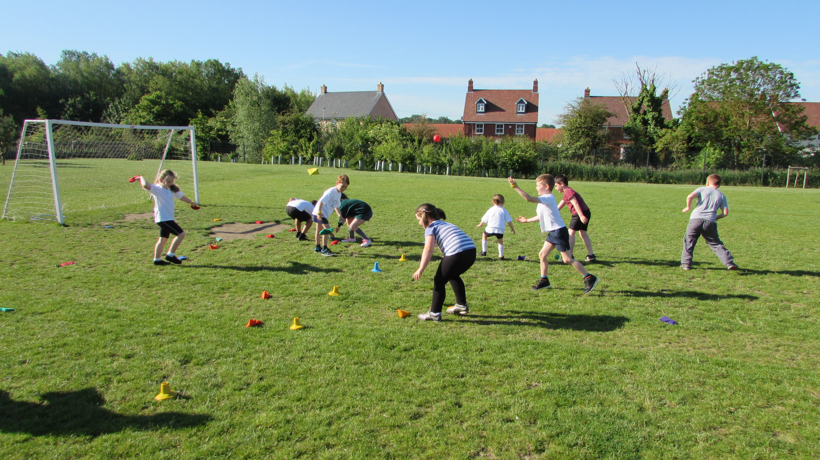

**Quote – Headteacher/staff**

Headteacher: “The profile of sport has been raised across the school with all pupils keen to take part and take a sense of pride in their sporting achievements. This was clearly evident on our Sport Relief Day when all children completed a Sport Relief Mile with pleasure and enjoyment!”

**Quote – Pupil(s)**

Pupil A: I love my Tuesday Sports Club and all of my friends wish they could come too!

Pupil B: My Mum used to drag me to C4L but now I have made friends and we play really cool games!

**Background**

* To give opportunities to groups of children who are disengaged from sport.
* To promote healthy lifestyles across the school.

**Actions**

* Targeting groups of children:
* Less active, SEND, Behaviour
* Engaging them in non sport specific physical activity.
* Making them active and alert ready for school day.
* Encourage them to enjoy physical activity in a non threatening and non competitive environment.
* Encourage them to have confidence to join other clubs.
* Breakfast club once a week from 8am. Two LSA’s running the club with a group of 20 children.

**Impact**

* Target groups now taking part in a weekly sporting club.
* Children relaxing and enjoying physical activity.
* Children making new friends across the school.
* Children teaching other friends games played at C4L in the playground.
* Children from C4L club signing up to take part in lunchtime sports clubs – tennis and multi sports.
* Children feeling a sense of achievement – receiving a certificate in whole school assembly.
* Commitment to the club – children having good attendance.
* Other pupils and parents showing an interest in the club therefore offering more active clubs as part of our whole school sport programme.
* Helped to promote healthy lifestyles across the school.

**How partners are supporting the school/cluster of schools to embed and sustain the activity**

Redborne School Partnership continues to promote Sport across the schools. It offers a range of children the chance to take part in sport in a range of different settings.

The Sports Ambassadors have played a key part this year in raising the whole school profile of sport and with the great training they receive from Redborne this has really helped us to embed healthy lifestyles across the school here at Roecroft.